Part-1:

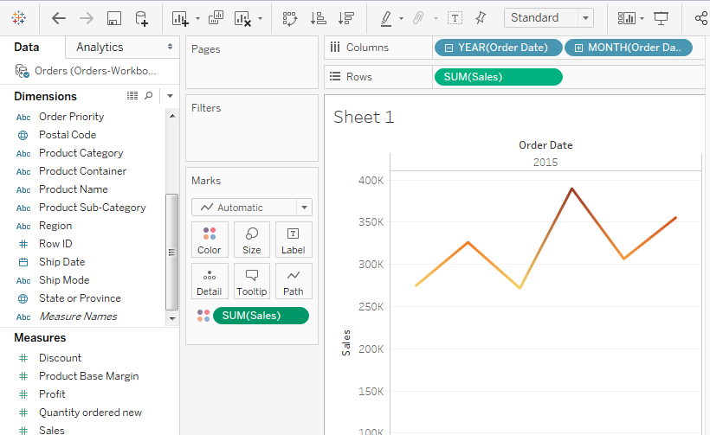

https://public.tableau.com/profile/mijanur.rahman#!/vizhome/OrdersandReturnsSuperstoreSales-Assignment1_15849610529750/Sheet1

Part-2:

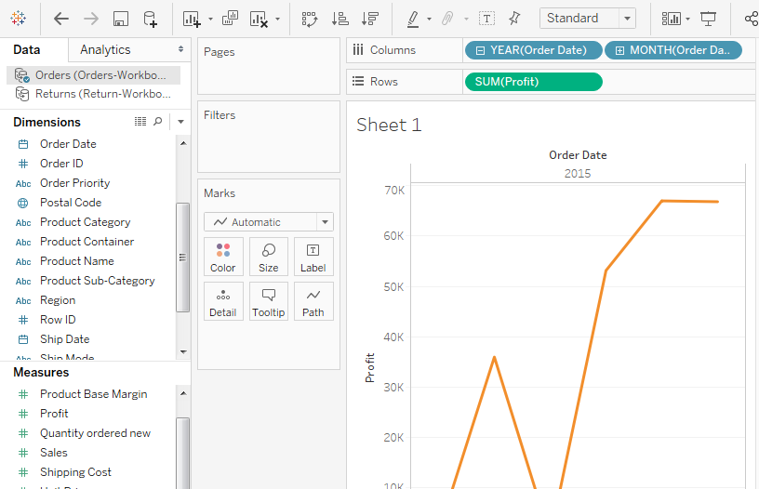

https://public.tableau.com/profile/mijanur.rahman#!/vizhome/Assignment-1_15849628290800/Sheet1?publish=yes

Part-3:

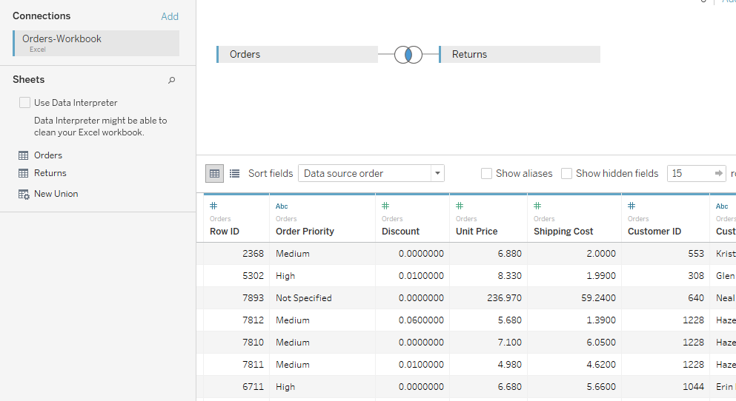

https://public.tableau.com/profile/mijanur.rahman#!/vizhome/Assignment-1-case-2/Sheet1?publish=yes